VISVESVARAYA TECHNOLOGICAL UNIVERSITY
BELAGAVI, KARNATAKA

PROJECT WORK PHASE I (ECEP23605)
Progress Report on
“Edge AI Based Predictive Maintenance System for Industrial Motors”
Submitted by
Mr. Yashas B Pujeri 1GA23EC185
Mr. Skanda Yogeesh 1GA23EC159
Mr. Sharath Kumar Y 1GA23EC144
Mr. Shashank B S 1GA23EC146

Under the Guidance of
Mrs. Bindu K
Assistant Professor



Department of Electronics and Communication Engineering
Global Academy of Technology
BENGALURU – 560098
2025-2026

GLOBAL ACADEMY OF TECHNOLOGY
An Autonomous Institute, affiliated to VTU Belagavi, Approved by AICTE, Accredited by NAAC, ‘A’ Grade
Department of Electronics & Communication Engineering

CERTIFICATE
Certified that the Project (ECEP23605) entitled
“Edge AI Based Predictive Maintenance System for Industrial Motors”
Carried out by,
Mr. Yashas B Pujeri 1GA23EC185
Mr. Skanda Yogeesh 1GA23EC159
Mr. Sharath Kumar Y 1GA23EC144
Mr. Shashank B S 1GA23EC146
Bonafide students of Global Academy of Technology in partial fulfillment for the award of Bachelor of Engineering in Electronics and Communication Engineering of the Visvesvaraya Technological University, Belagavi during the academic year 2025-26. It is certified that all corrections/suggestions indicated for Internal Assessment have been incorporated in the report deposited in the Departmental library. The project report has been approved as it satisfies the academic requirements in respect of project work prescribed for the said Degree.

Signature of the Guide Signature of the HOD Signature of the Principal
Mrs. Bindu K Dr. Madhavi Mallam Dr. H B Balakrishna

External Viva
Name of the Examiners Signature with Date
1.

2.

ACKNOWLEDGEMENT

It is our privilege to acknowledge with profound regards, grateful to the Management of GLOBAL ACADEMY OF TECHNOLOGY for their encouragement and continuous support.

We are grateful to Dr. H B BALAKRISHNA, Principal, Global Academy of Technology, Bengaluru for giving us the opportunity to do this project, which is submitted as partial fulfilment for the 6th semester exams.

We thank Dr. MADHAVI MALLAM, Head of the Department of Electronics and Communication Engineering, Global Academy of Technology for her consistent motivation and encouragement.

We are thankful for the guidance shown by our esteemed and beloved guide Mrs. Bindu K, Assistant professor, Department of Electronics and Communication Engineering, whose wisdom and experience has enabled us to conduct this project successfully.

Finally, we sincerely thank to teaching and non-teaching staff those who have directly or indirectly supported and helped us.

Mr. Yashas B Pujeri 1GA23EC185
Mr. Skanda Yogeesh 1GA23EC159
Mr. Sharath Kumar Y 1GA23EC144
Mr. Shashank B S 1GA23EC146

ABSTRACT
This project presents the design and implementation of an Edge AI-based Predictive Maintenance (PdM) System specifically engineered for industrial motors. Traditional maintenance strategies often rely on periodic schedules or reactive "run-to-failure" approaches, which lead to significant downtime and high operational costs. This system shifts the paradigm toward proactive intelligence by deploying machine learning models directly onto localized hardware at the "edge."
The proposed architecture utilizes a suite of sensors—primarily tri-axial accelerometers and current sensors—to capture high-frequency vibration and electrical signatures. Unlike cloud-centric models that suffer from high latency and bandwidth constraints, this system processes raw data locally using an optimized Artificial Neural Network (ANN) or Support Vector Machine (SVM). To ensure compatibility with resource-constrained microcontrollers, the model undergoes post-training quantization, reducing the memory footprint while maintaining high diagnostic accuracy.
The system is capable of identifying common motor faults, such as bearing wear, misalignment, and stator winding failures, in real-time. Experimental results demonstrate that the Edge AI approach provides a significant reduction in data transmission requirements and offers instantaneous alerting capabilities, even in environments with intermittent connectivity. This project concludes that integrating intelligence at the edge provides a scalable, secure, and cost-effective solution for enhancing the reliability and lifespan of critical industrial assets.

TABLE OF CONTENTS

ACKNOWLEDGEMENT i

ABSTRACT ii

TABLE OF CONTENTS iii

LIST OF FIGURES iv

CHAPTER 1 INTRODUCTION 1
1.1 About the Topic
1.2 Problem Statement
1.3 Objectives
1.4 Sustainable Development Goals

CHAPTER 2 LITERATURE SURVEY 4

CHAPTER 3 METHODOLOGY 10
3.1 Introduction
3.2 Block Diagram
3.3 Components used
3.2.1 Hardware components
3.2.2 Software

CHAPTER 4 IMPLEMENTATION 19
4.1 Introduction
4.2 Flow chart
4.3 Results
4.3.1 Working of the System
4.3.2 Results Explanation

REFERENCE 27

LIST OF FIGURES

Figure No. | Name of the Figure | Page No.
3.2.1 Block Diagram 12

3.3.1.1 Motor 13

3.3.1.2 Microcontroller 14

3.3.1.3 Vibration sensor 14

3.3.1.4 Current sensor 15

3.3.1.5 External ADC 15

3.3.1.6 Temperature sensor 16

3.3.1.7 Motor Driver 16

3.3.1.8 Buck Converter 17

4.2.1 Flow Chart of Implementation 21

4.3.2.1 Circuit Design 26

4.3.2.2 Dashboard for displaying the result 26

CHAPTER 1
INTRODUCTION
  - About the Topic

Industrial motors are the backbone of modern manufacturing and production facilities, powering everything from conveyor belts and pumps to compressors and machine tools. These motors operate continuously under demanding conditions, making them highly susceptible to wear, fatigue, and unexpected failures. An unplanned motor breakdown can halt entire production lines, resulting in significant financial losses, safety hazards, and costly emergency repairs.Traditionally, motor maintenance has followed either a reactive approach (fixing after failure) or a preventive approach (scheduled maintenance at fixed intervals). While preventive maintenance reduces sudden breakdowns, it often leads to unnecessary servicing of healthy equipment, wasting time and resources. Neither approach is optimal for today's high-demand industrial environments.This is where Predictive Maintenance (PdM) emerges as a game-changing solution. Predictive maintenance involves continuously monitoring the health of equipment and predicting failures before they occur, allowing maintenance to be scheduled only when truly needed. It leverages real-time sensor data such as vibration, temperature, current, and acoustic signals to detect early signs of degradation.The integration of Artificial Intelligence (AI) with predictive maintenance has dramatically enhanced its accuracy and reliability. Machine learning models can identify complex fault patterns in motor behavior that are impossible to detect through traditional threshold-based monitoring.However, sending massive volumes of sensor data to centralized cloud servers introduces challenges such as high latency, bandwidth limitations, data privacy concerns, and dependency on internet connectivity. This has driven the adoption of Edge AI — the deployment of AI algorithms directly on local edge devices situated close to the motors themselves.Edge AI-based predictive maintenance systems combine the intelligence of AI with the speed and efficiency of edge computing, enabling real-time fault detection, reduced response times, lower communication costs, and uninterrupted operation even in offline environments.This approach represents the next frontier in Industry 4.0, transforming how industries monitor, maintain, and optimize their motor-driven systems for maximum reliability and efficiency.

  - Problem Statement
Early-stage faults in industrial motors manifest as subtle changes in vibration and current patterns that are difficult to detect through manual inspection or periodic maintenance schedules. Run-to-failure strategies often lead to unexpected breakdowns, secondary equipment damage, and higher repair costs. Therefore, there is a need for a low-cost embedded system capable of real-time motor condition monitoring and intelligent fault detection at the edge.
  - Objectives
- To design and develop an embedded data acquisition system capable of capturing high-frequency vibration, current, and temperature signals from industrial induction motors.
- To implement localized digital signal processing techniques, such as Fast Fourier Transform (FFT), to extract critical frequency-domain features directly at the edge.
- To develop and train a lightweight Machine Learning model (such as an ANN or SVM) capable of classifying motor health states and detecting early-stage faults.
- To optimize the trained model using quantization and pruning techniques for deployment on resource-constrained microcontrollers with minimal latency.
- To establish a real-time alerting mechanism that identifies anomalies and triggers protective actions without requiring continuous cloud connectivity.
- To evaluate the system's performance in terms of classification accuracy, inference time, and power consumption compared to traditional cloud-based monitoring solutions

  - Sustainable Development Goals
SDG 7: Affordable and Clean Energy Justification: Industrial motors are responsible for a massive portion of global electricity consumption. When a motor operates with faults—such as bearing friction, winding imbalances, or misalignment- it draws significantly more current to maintain the same torque, leading to energy "leakage." By using Edge AI to ensure motors run at peak health, the system minimizes these electrical losses.
SDG 8: Decent Work and Economic Growth Justification: Unplanned downtime is a primary driver of economic loss in manufacturing. Sudden motor failure can halt entire production lines, leading to idle labor and lost revenue. This project promotes economic stability by transforming maintenance from a "crisis response" model to a "predictive" model.
SDG 9: Industry, Innovation and Infrastructure Justification: This project is a direct application of Industry 4.0 principles. By moving AI from high-powered servers to low-cost microcontrollers at the "Edge," it introduces sophisticated infrastructure to even small-scale industrial setups.
SDG12: Responsible Consumption and Production Justification: Traditional "periodic" maintenance often results in the disposal of perfectly functional parts simply because they reached a specific date on a calendar. Conversely, "run-to-failure" often results in the total destruction of the motor, requiring a full replacement.

CHAPTER 2
LITERATURE SURVEY
Montes-Sánchez et al. [1] have addressed the critical challenge of real-time motor health monitoring by proposing an integrated Edge-AI and IoT-based predictive maintenance device for electric motors. Their work focuses on multi-modal sensor fusion, wherein data from vibration, current, and temperature sensors are simultaneously collected and fused to create a comprehensive picture of motor health. The core contribution lies in performing all data processing and AI inference locally at the edge, eliminating cloud dependency and ensuring near real-time fault alerts. The IoT integration layer allows the system to transmit summarized health reports to remote monitoring dashboards, enabling plant managers to track motor conditions from any location. The system significantly reduces communication latency and ensures uninterrupted operation even during network disruptions. However, the study lacks real-world industrial validation and was not tested under actual factory floor conditions with electromagnetic interference and variable loads. The paper does not provide detailed algorithmic descriptions of the sensor fusion process, making replication difficult. There is also no concrete discussion on hardware implementation aspects such as microcontroller selection and power requirements. The system lacks detailed performance benchmarking against existing solutions, reducing confidence in its claimed advantages. These significant gaps must be addressed before the system can be considered production-ready for real industrial deployment.

Rojas, Peña, and Garcia et al. [2] have addressed unexpected tool and spindle failures in CNC machines by proposing an AI-driven predictive maintenance application combining LSTM networks and Random Forest classifiers. LSTM effectively captures long-term temporal dependencies in sequential vibration signals while Random Forest handles noisy industrial data through ensemble-based classification. Training both models on vibration datasets from CNC machines under various fault conditions demonstrated significantly improved failure prediction accuracy over conventional methods. The system monitors spindle vibration and cutting force signatures, extracting statistical and frequency-domain features for real-time health assessment, enabling early detection of tool wear and bearing degradation. However, the system relies entirely on centralized cloud processing, introducing high latency, data privacy concerns, and vulnerability to network outages. It also requires large labeled datasets for acceptable accuracy, limiting scalability for smaller manufacturing facilities without extensive historical fault data.

Montes-Sánchez et al. [3] have addressed early-stage aging detection in peristaltic pumps by deploying RNN models on local edge hardware for real-time fault inference without cloud dependency. Their system recorded data using six sensors including accelerometers, gyroscope, magnetometer, and microphone, capturing temporal signal evolution as pumps age over their operational life. The edge deployment ensures consistently low latency and uninterrupted monitoring even in network-isolated industrial environments. The publicly available multi-sensor dataset recorded at high sampling frequencies is a valuable contribution to the research community. The system demonstrated strong capability to predict remaining useful life, providing maintenance teams with sufficient lead time for timely interventions. However, the RNN model is specifically tailored for peristaltic pumps and requires significant re-tuning for other equipment types. The model involves complex training pipelines demanding considerable machine learning expertise. The study also does not address how the system handles concept drift when signal statistics change over time due to changing operational conditions.

Khatun, Z. et al. [4] have addressed the integration of AI-based fault detection into existing SCADA systems in smart manufacturing facilities by proposing a SCADA-to-Edge deployment framework. Their system combines vibration, current, acoustic, and thermal sensor data using CNN models, enabling manufacturers to upgrade predictive maintenance capabilities without replacing existing infrastructure. The CNN approach automatically learns hierarchical feature representations, eliminating manual feature engineering. Multi-modal sensor fusion provides a holistic view of motor health, simultaneously capturing electrical, mechanical, thermal, and acoustic fault signatures. The system demonstrated improved fault detection accuracy and reduced response time compared to purely cloud-based approaches. However, the system demands high computational resources unsuitable for low-cost microcontrollers, requiring expensive edge hardware platforms. Integration with diverse SCADA platforms from different vendors involves complex compatibility challenges, increasing deployment time, engineering overhead, and overall system maintenance complexity considerably.

Baradaran, A.H. et al. [5] have addressed the selection of optimal supervised learning algorithms for edge-based motor fault detection through a systematic comparative study evaluating SVM, Random Forest, KNN, Decision Trees, and lightweight Neural Networks. Each model was assessed not only on classification accuracy but also on inference time, memory footprint, and energy consumption, which are critical metrics for edge microcontroller deployment. Results showed that SVM and Random Forest consistently offer the best performance-resource trade-off for edge deployment, while deeper networks provide higher accuracy at greater computational cost. The study also investigated the impact of combining time-domain features such as RMS and kurtosis with frequency-domain FFT features, demonstrating significantly improved classification performance across all models. However, the study involves complex training pipelines requiring significant machine learning expertise, making replication difficult for industrial practitioners. The models were trained under fixed load and speed conditions, showing limited adaptability to variable operational environments encountered in real industrial settings.

Zhou, Qiao, Lin, Li, Wu, and Yu et al. [6] have addressed efficient deployment of AI-based fault diagnosis on edge devices by integrating Multi-Scale CNN, LSTM networks, and attention mechanisms for servo motor fault detection. The multi-scale CNN captures fault features at multiple temporal resolutions, LSTM models sequential signal dependencies, and the attention mechanism focuses on the most diagnostically informative signal segments. The study systematically compares SCADA-based, edge-based, and hybrid deployment architectures in terms of accuracy, latency, and complexity. Knowledge distillation and model quantization were applied to optimize the model for resource-constrained edge hardware, achieving efficient inference with minimal accuracy loss. The experimental results confirmed excellent diagnostic accuracy and inference speed on embedded edge processors. However, the hybrid architecture introduces higher communication latency due to cloud round-trip overhead, and integration with legacy SCADA systems adds significant engineering complexity requiring expertise in both industrial automation and AI development.

Khatun, Z. et al. [7] have addressed predictive maintenance in automotive manufacturing by proposing an edge analytics framework using CatBoost gradient-boosting algorithm for high-accuracy motor fault classification. CatBoost natively handles imbalanced datasets and categorical features, significantly reducing preprocessing burden compared to other algorithms. The framework processes sensor data locally on edge hardware, reducing cloud dependency and enabling faster maintenance decisions on the factory floor. Feature importance analysis provides maintenance engineers with interpretable insights into which sensor features contribute most to fault classification decisions. The system demonstrated superior classification accuracy compared to traditional algorithms such as Logistic Regression and Decision Trees on combined vibration and current datasets. However, the system lacks real-time edge implementation, operating entirely in offline batch processing mode. It depends on static pre-computed parameters, making it unsuitable for dynamic continuous monitoring scenarios where operating conditions change frequently over time.

The authors of "AI-Based Multi-Signals Fault Diagnosis of Induction Motor" et al. [8] have addressed the limitation of single-source fault diagnosis by proposing a comprehensive multi-source approach using vibration, current, acoustic, and thermal sensors under varied load and speed conditions. Features were extracted across time, frequency, and time-frequency domains for ML classification, while sensor data was transformed into scalogram images for 2D CNN-based deep learning inference. ML models achieved up to 96% classification accuracy on individual sensor channels under controlled conditions. The MobileNet-based edge deployment significantly reduced data transmission bandwidth and inference latency compared to cloud-dependent approaches. The system can simultaneously detect multiple fault types including bearing damage, stator winding failures, and broken rotor bars. However, multi-sensor data fusion showed reduced performance in some experimental configurations, suggesting the fusion strategy requires further optimization. The system is also limited in its ability to handle complex overlapping fault conditions generating similar spectral signatures across multiple sensor modalities.

The authors of "Edge Computing and Fault Diagnosis of Rotating Machinery Based on MobileNet" et al. [9] have addressed real-time fault diagnosis of rotating machinery by deploying lightweight MobileNet CNN models on STM32 microcontrollers within wireless sensor networks for mechanical vibration analysis. MobileNet's depthwise separable convolution architecture achieves a favorable accuracy-complexity trade-off specifically designed for microcontroller-class hardware deployment. The wireless sensor network enables cable-free distributed sensing, with each node performing local AI inference and transmitting only compact classification results rather than raw vibration data, significantly reducing bandwidth consumption and battery energy usage. Experiments demonstrated that embedded MobileNet models can accurately distinguish between healthy operation and multiple bearing fault conditions including inner race, outer race, and rolling element defects. The approach supports real-time monitoring of rotating machinery on low-power embedded hardware platforms effectively. However, the study lacks comprehensive performance metrics and detailed confusion matrix analysis for individual fault classes. Scalability evaluation for large-scale industrial deployment scenarios involving multiple simultaneously monitored machines connected through shared wireless networks was not addressed.

The authors of "Predictive Maintenance of Industrial Machine Using Edge AI" et al. [10] have addressed reliable fault detection on low-power edge devices by proposing a framework deploying lightweight ML classifiers and compact CNN architectures on embedded microcontrollers for real-time industrial machine condition monitoring. The system captures vibration and current signals using low-cost MEMS accelerometers and Hall-effect sensors, extracts time and frequency domain features on the embedded processor, and performs instant fault classification without cloud latency. Depthwise separable convolutions, channel pruning, and post-training integer quantization were applied to minimize computational requirements while preserving acceptable diagnostic accuracy. The system demonstrated high classification accuracy on low-power devices, validating the feasibility of edge AI for industrial predictive maintenance. The approach also significantly reduces data transmission costs and enhances data privacy through fully local processing. However, the work focuses primarily on machining tools rather than rotating electrical motors, requiring substantial system redesign, sensor reconfiguration, and complete model retraining for effective application to induction motor fault detection scenarios.

Artiushenko, Lang, Lerez, Reggelin, and Hackert-Oschätzchen et al. [11] have addressed the development of a lightweight and resource-efficient predictive maintenance solution for edge devices using CNN-based acoustic signal analysis for tool condition monitoring in manufacturing operations. The CNN architecture was deliberately designed with minimal parameters to enable deployment on microcontroller-class hardware, and post-training quantization reduced model size by approximately 4x with only marginal accuracy degradation. The system captures acoustic emission signals from machining operations, extracts relevant features using the compact CNN, and performs real-time tool wear classification entirely on the edge device. The approach demonstrated near-zero inference latency, complete cloud independence, reduced data storage requirements, and enhanced data privacy through fully local processing. The lightweight edge deployment proved computationally efficient and practically viable for continuous industrial monitoring. However, the system relies exclusively on acoustic data without any multi-sensor integration, significantly limiting its ability to detect the full spectrum of motor fault types. Electrical winding failures, bearing lubrication deficiencies, and thermal anomalies produce minimal acoustic signatures at early stages, reducing overall system diagnostic reliability considerably.

CHAPTER 3
METHODOLOGY
3.1 Introduction
The proposed Edge-AI Based Predictive Maintenance System for Industrial Motors is designed as a comprehensive, intelligent, and fully embedded solution that enables real-time motor health monitoring and fault detection without dependency on cloud infrastructure. The system follows a structured ten-stage pipeline that transforms raw sensor data into actionable maintenance intelligence directly at the edge, ensuring minimal latency, continuous operation, and immediate fault response.The system is built around the ESP32-WROOM-32 microcontroller as the central processing unit, chosen for its dual-core architecture, integrated WiFi capability, and sufficient computational power to support embedded machine learning inference. Upon system startup, the ESP32 initializes all peripheral sensors, establishes WiFi connectivity, and configures the MQTT communication protocol, laying the foundation for real-time data acquisition and transmission.For sensor data acquisition, the system employs three dedicated sensing modalities. The MPU6050 tri-axis accelerometer captures high-frequency vibration and rotational data, enabling detection of imbalance, misalignment, bearing faults, and shaft instability. The ACS712 current sensor continuously monitors motor current draw to identify overload conditions and abnormal current fluctuations indicative of electrical faults. The temperature sensor measures motor winding and bearing temperature to detect overheating and insulation degradation risks. These three sensor streams collectively provide a holistic and multi-dimensional view of motor health in real time.Raw sensor data is acquired and passed through a feature extraction stage, where meaningful statistical and signal-processing features including Vibration RMS, Kurtosis, Crest Factor, and Current RMS are computed directly on the ESP32 processor. These features effectively represent the underlying health characteristics of the motor and serve as inputs to the machine learning model.The extracted features are fed into a Random Forest machine learning model deployed on the ESP32 using TensorFlow Lite, which classifies the motor health status into three distinct categories Normal, Warning, and Danger. This embedded inference approach eliminates cloud round-trip latency and ensures fault detection occurs in real time regardless of network availability.Upon fault classification, the Fault Alert System immediately triggers appropriate physical indicators. A green LED signals normal operation, while a warning condition activates a red LED with a slow buzzer, and a danger condition triggers a red LED with a fast buzzer, providing instant on-site visual and audible alerts to maintenance personnel on the factory floor.The classified results and sensor readings are then structured into JSON payloads containing motor status information, which are published over the MQTT protocol via WiFi to the Mosquitto MQTT Broker. The broker efficiently distributes these messages to all subscribed clients across the monitoring network. Finally, a Node-RED dashboard receives the data and presents real-time gauges, live graphs, motor status indicators, and historical trend visualizations, enabling remote monitoring and data-driven maintenance decision-making from any connected device.This end-to-end pipeline represents a complete, scalable, and cost-effective implementation of Edge-AI based predictive maintenance, bringing intelligent motor diagnostics directly to the industrial floor.

3.2 Block Diagram
The proposed Edge-AI Based Predictive Maintenance System for Industrial Motors follows a structured ten-stage pipeline that transforms raw sensor data into actionable maintenance intelligence directly at the edge.
The process begins with System Startup, where the ESP32 microcontroller boots up, initializes all connected sensors, establishes WiFi connectivity, and configures the MQTT communication protocol for data transmission.
In the Sensor Acquisition stage, three sensors are employed simultaneously. The MPU6050 accelerometer captures vibration and rotational data to detect imbalance, misalignment, bearing faults, and shaft instability. The ACS712 current sensor monitors motor current to identify overload and abnormal electrical conditions. The temperature sensor measures motor heat to detect overheating and insulation degradation risks.
During Sensor Data Reading, raw data is continuously acquired from all three sensors and passed to the next processing stage. In the Feature Extraction stage, meaningful statistical features including Vibration RMS, Kurtosis, Crest Factor, and Current RMS are computed directly on the ESP32, converting raw signals into diagnostically relevant representations.
These extracted features are fed into the ML Fault Analysis stage, where a Random Forest model deployed on the ESP32 classifies motor health into three categories — Normal, Warning, and Danger — enabling real-time embedded inference without cloud dependency.
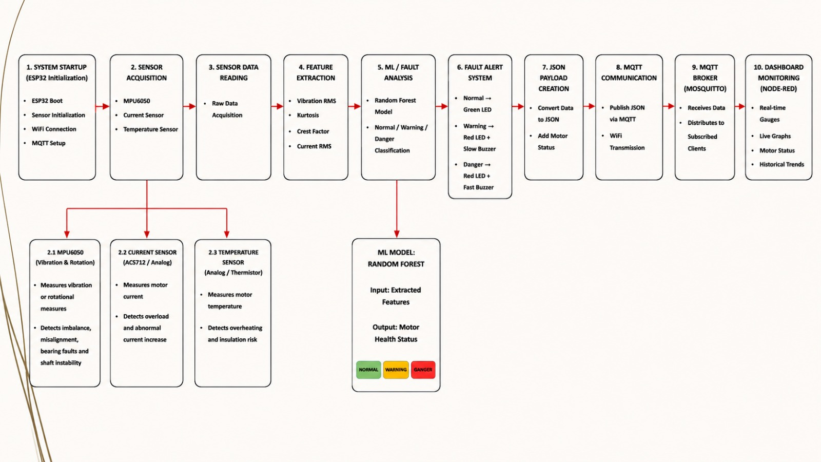
Figure 3.2.1 Block diagram

Based on classification results, the Fault Alert System triggers appropriate indicators. Normal condition activates a green LED, Warning activates a red LED with slow buzzer, and Danger activates a red LED with fast buzzer, providing immediate on-site alerts.
The results are then structured into JSON Payloads containing motor status information, which are published via MQTT Communication over WiFi. The Mosquitto MQTT Broker receives and distributes these messages to all subscribed clients. Finally, the Node-RED Dashboard presents real-time gauges, live graphs, motor status, and historical trends, enabling comprehensive remote monitoring and data-driven maintenance decisions.

3.3 Components used
3.3.1 Hardware components:
3.3.1.1 Motor:
A 0.1 HP single-phase capacitor-run induction motor is used, operating at a rated voltage of 220V AC and frequency of 50 Hz with a speed of 1440 RPM. It is foot-mounted (B3 frame) and equipped with ball bearings to enable fault signature generation. This motor is suitable for laboratory-scale testing due to its safety and ability to produce realistic fault conditions.
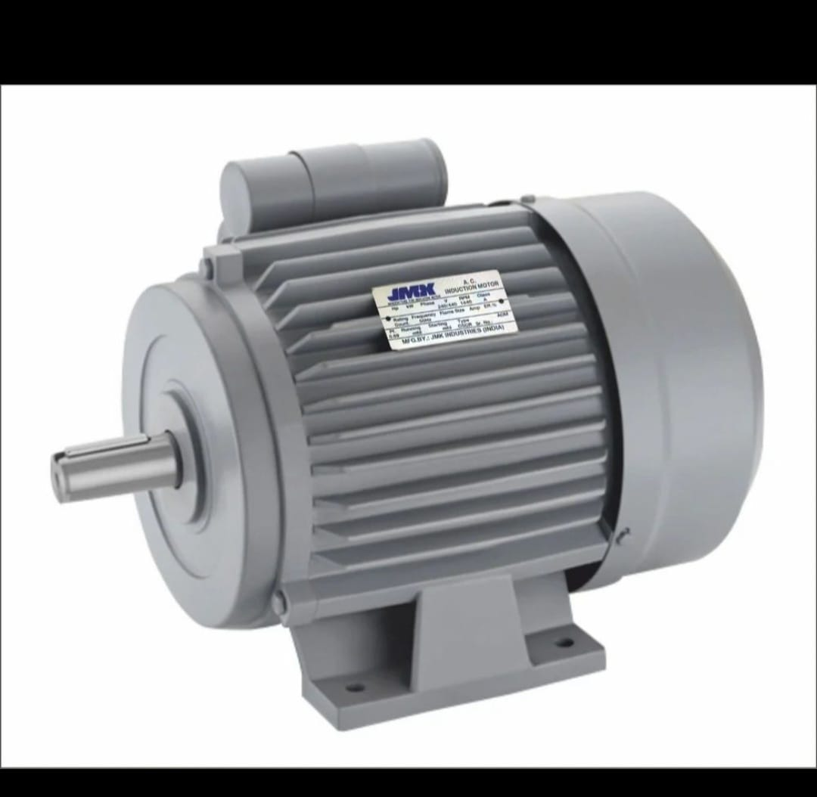
Figure 3.3.1.1 Motor

3.3.1.2 Microcontroller:
The ESP32-WROOM-32 DevKit V1 (38-pin) is used as the core processing unit. It features a dual-core Xtensa LX6 processor operating up to 240 MHz, 520 KB SRAM, and integrated WiFi (802.11 b/g/n) and Bluetooth (v4.2). It operates at 3.3V and supports multiple interfaces such as GPIO, ADC, DAC, I2C, SPI, and UART.
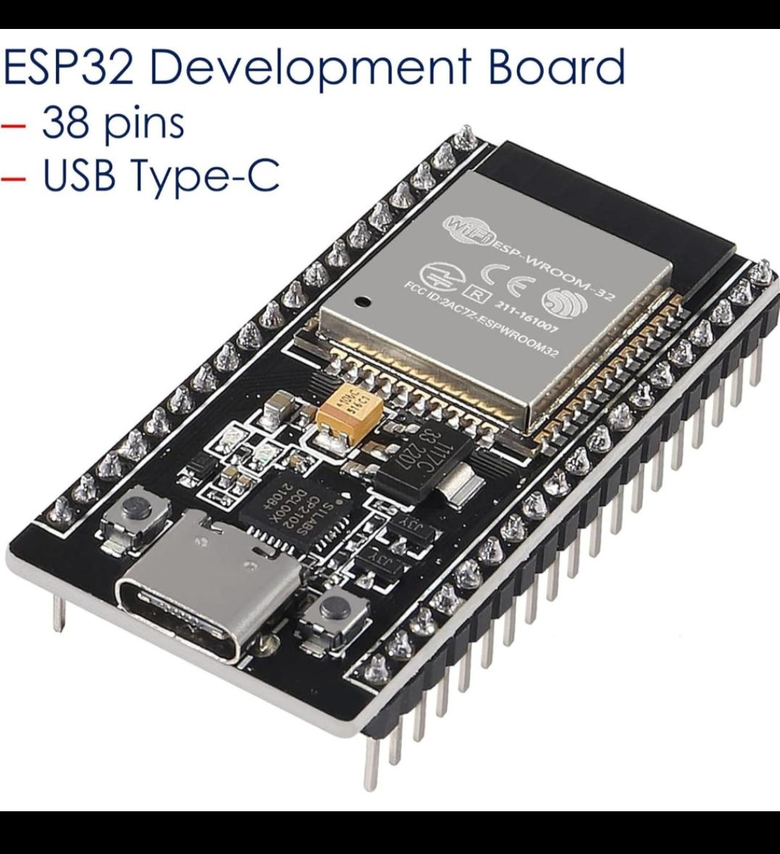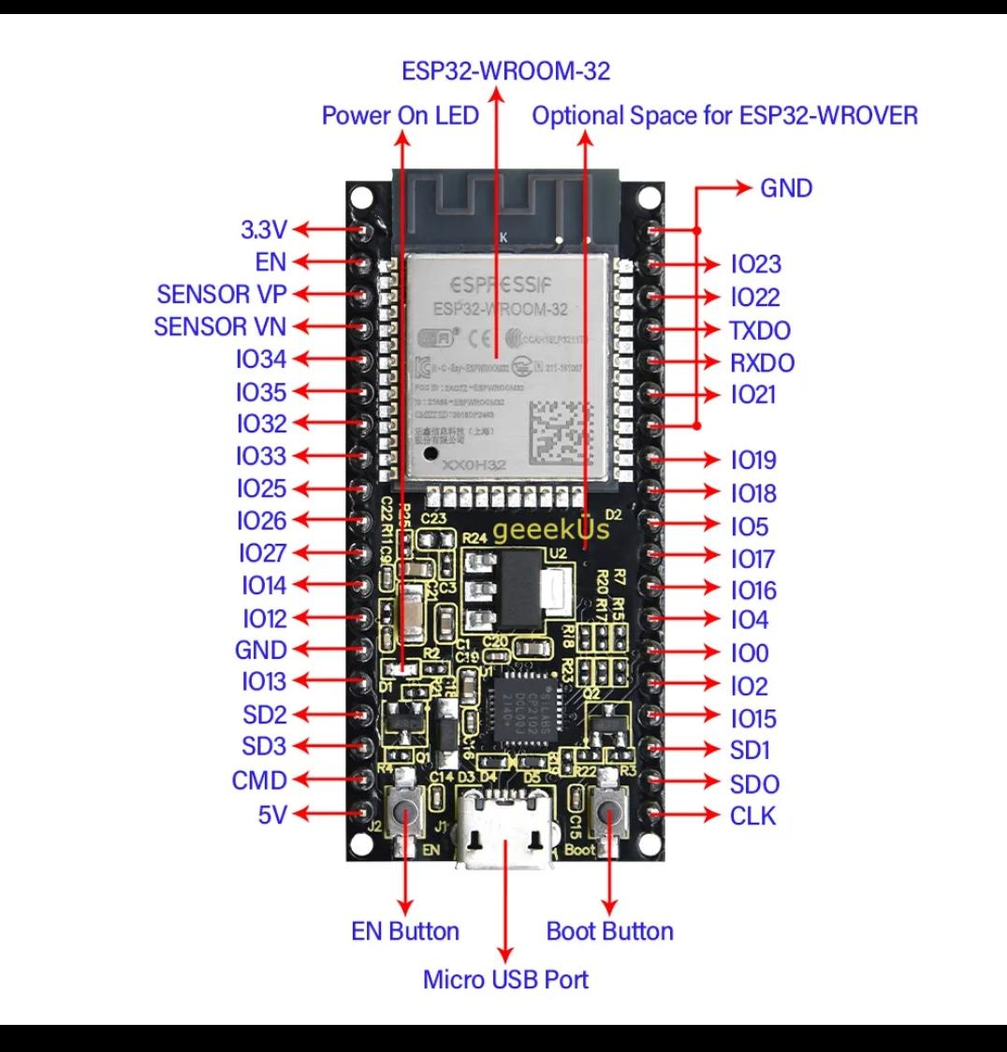
Figure 3.3.1.2 Microcontroller [ESP32]
3.3.1.3 Vibration Sensor:
The ADXL345 is a 3-axis digital accelerometer (GY-291 module) used for vibration measurement. It supports measurement ranges of ±2g, ±4g, ±8g, and ±16g with 13-bit resolution. It communicates via I2C or SPI and has low power consumption of approximately 23 µA in measurement mode, making it suitable for motion and vibration detection.
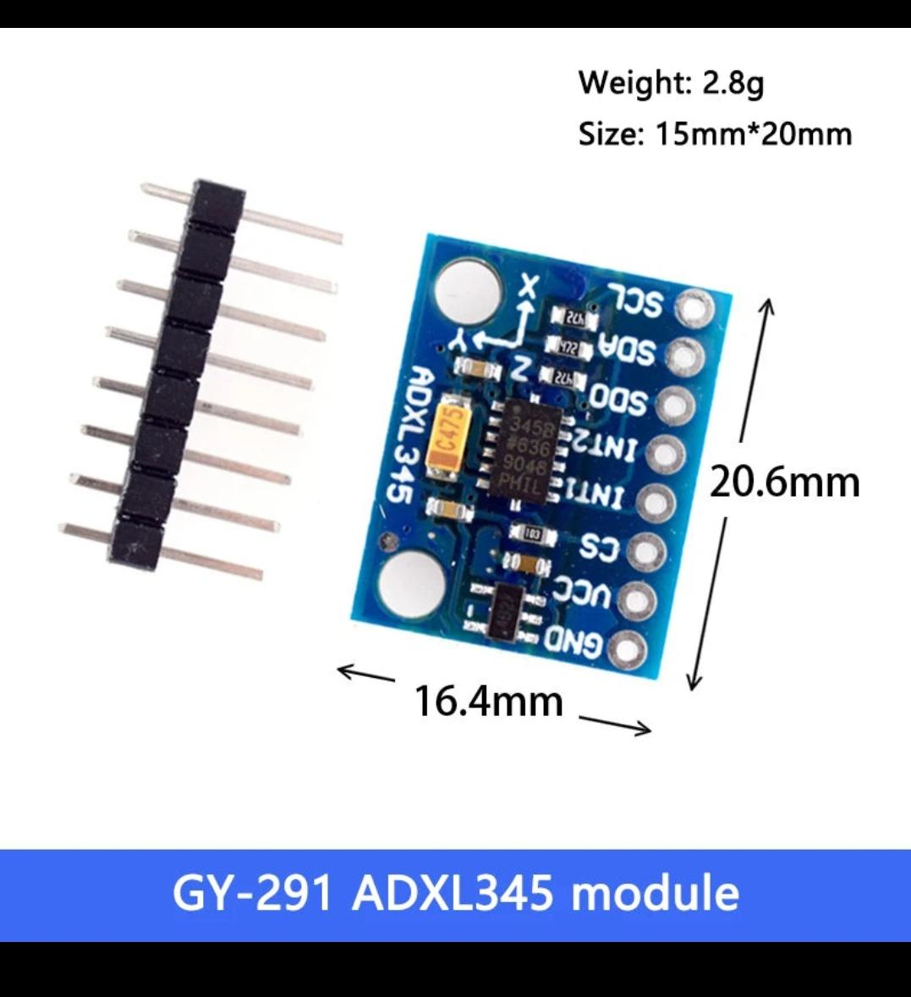
Figure 3.3.1.3 Vibration Sensor
3.3.1.4 Current Sensor:
The ACS712-05B is a Hall-effect based current sensor used to measure electrical current. It has a measurement range of ±5A with a sensitivity of 185 mV/A and operates at a supply voltage of 5V. It provides an analog output proportional to the current and has a bandwidth of 80 kHz, along with electrical isolation.
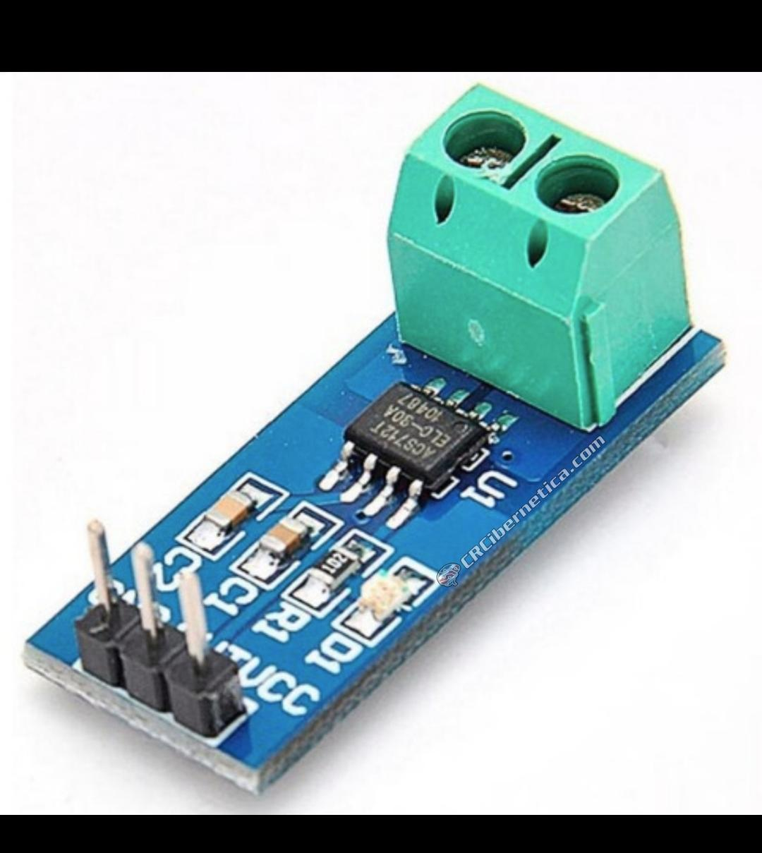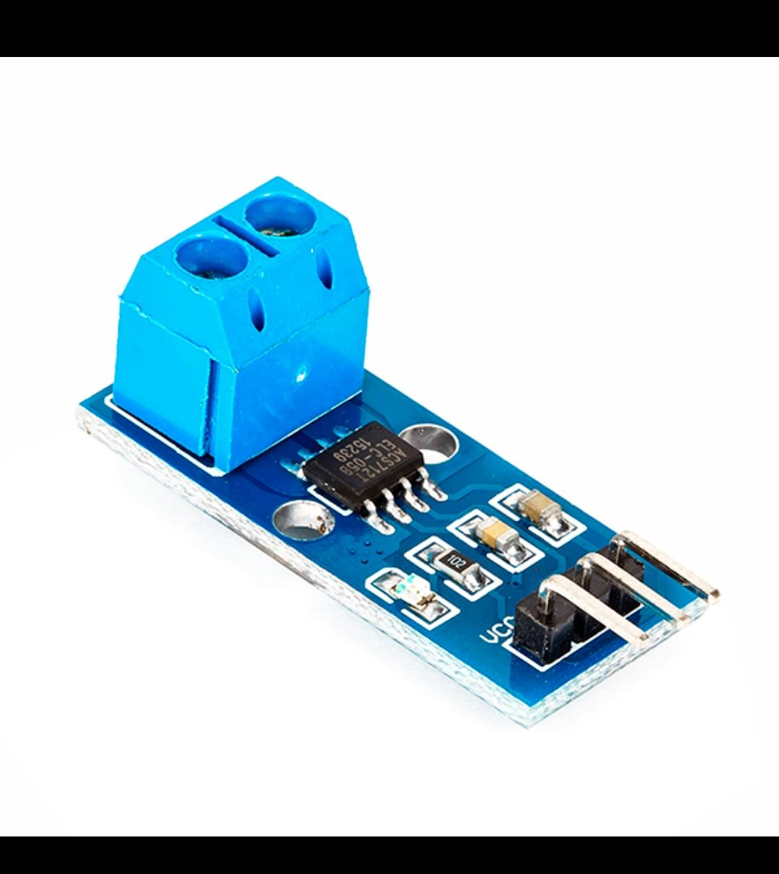
Figure 3.3.1.4 Current Sensor
3.3.1.5 External ADC:
The ADS1115 is a 16-bit analog-to-digital converter with 4-channel input capability. It includes a programmable gain amplifier (PGA) and communicates via the I2C interface. It supports a sampling rate of up to 860 samples per second, providing high resolution for accurate signal acquisition.
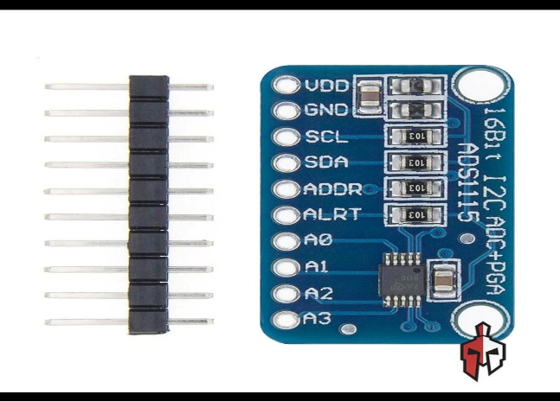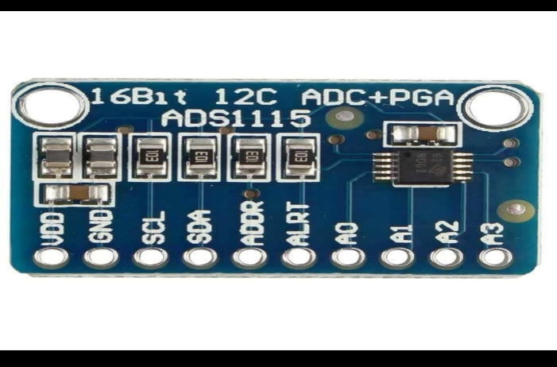
Figure 3.3.1.5 External ADC
3.3.1.6 Temperature Sensor:
The DS18B20 is a digital temperature sensor with a measurement range of −55°C to +125°C and an accuracy of ±0.5°C in the range of −10°C to +85°C. It uses a 1-wire communication protocol and comes with a waterproof stainless-steel probe and a 1-meter cable.
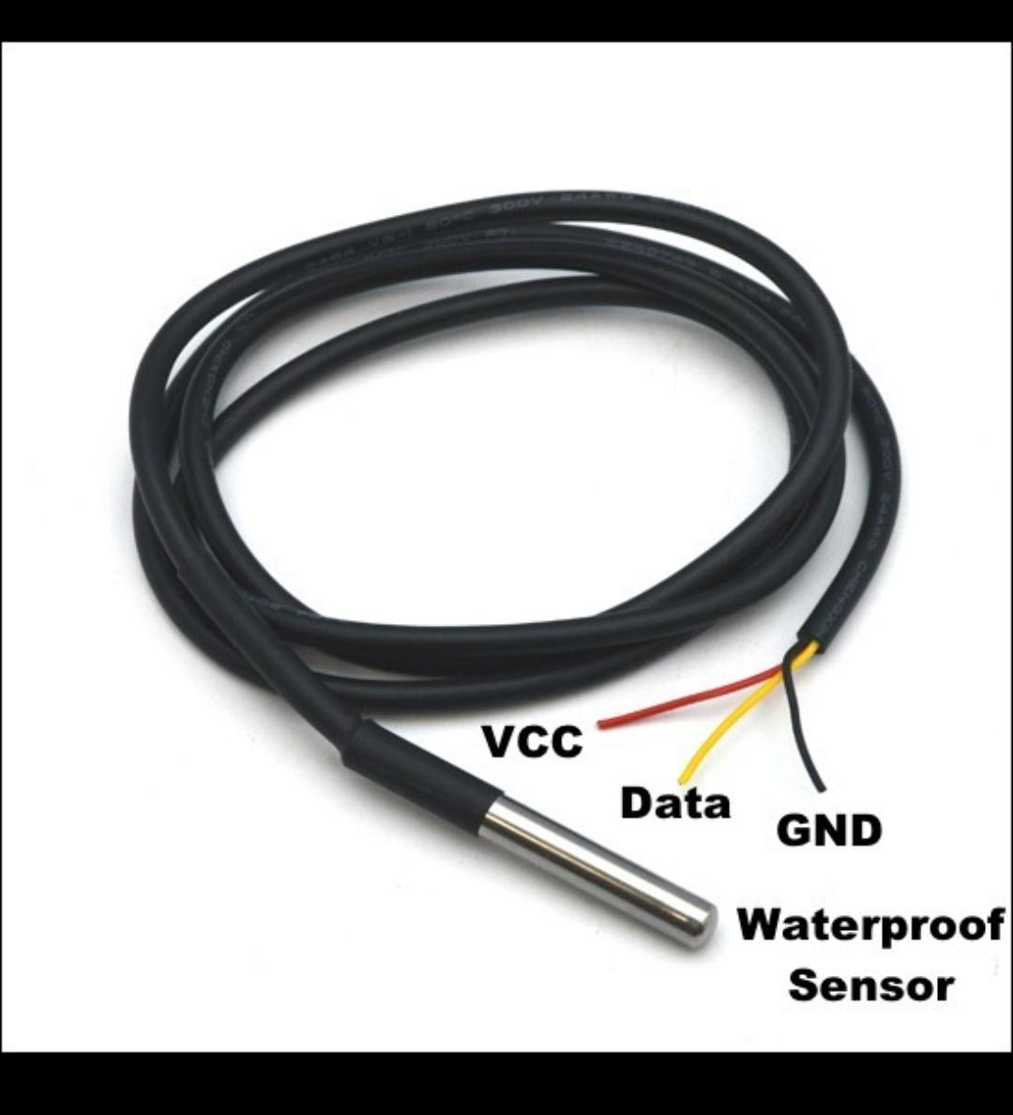
Figure 3.3.1.6 Temperature Sensor
3.3.1.7 Motor Driver:
The L298N is a dual H-bridge motor driver module capable of operating up to 46V with a current output of up to 2A per channel. It supports bidirectional motor control and includes an onboard 5V regulator. It is used for controlled motor operation and soft starting.
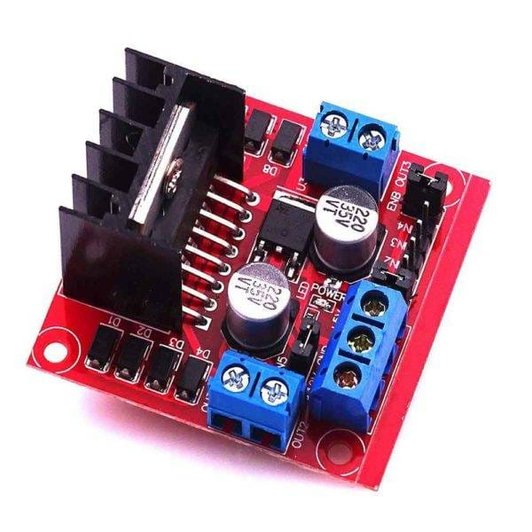
Figure 3.3.1.7 Motor Driver
3.3.1.8 Buck Converter:
The LM2596 is a DC-DC step-down (buck) converter module with an input voltage range of 4V to 40V and an adjustable output voltage from 1.25V to 37V. It can deliver up to 3A output current with high efficiency of around 80–90%, ensuring stable voltage regulation.
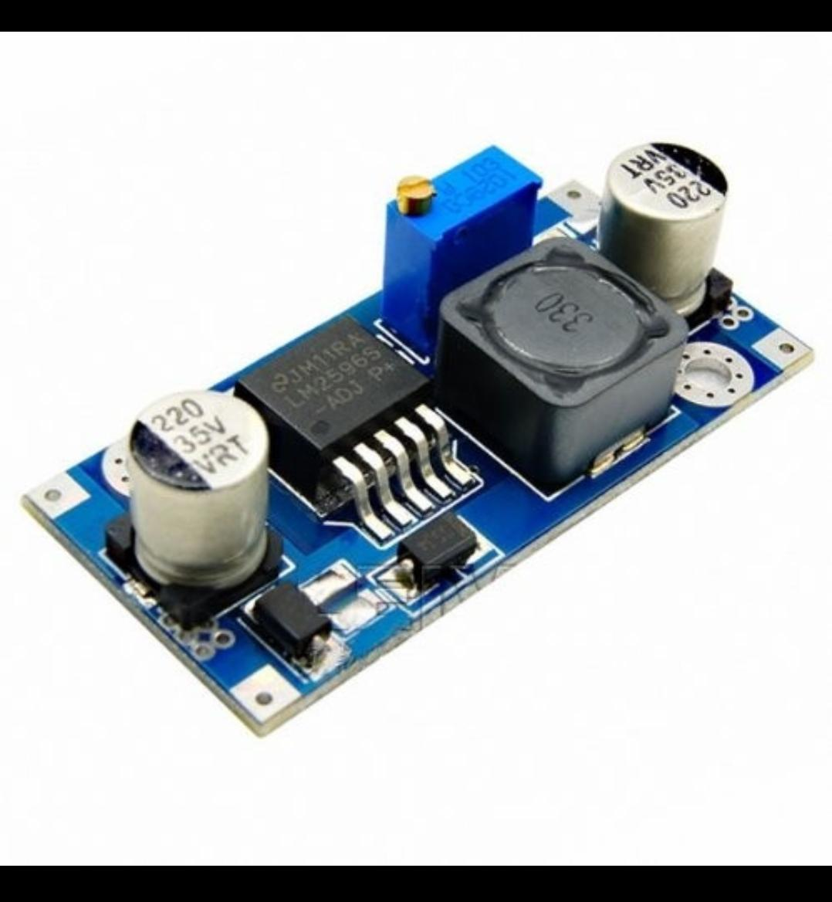
Figure 3.3.1.8 Buck Converter
3.3.2 Software Components:
3.3.2.1 Programming Language:
Python is used for data processing and model development. It provides powerful libraries such as NumPy, Pandas, and SciPy for efficient data analysis and signal processing. It is widely used in machine learning, making it suitable for rapid prototyping and model training.
3.3.2.2 Development Environment:
Arduino IDE is used for ESP32 firmware development. It is simple, beginner-friendly, and well-supported for ESP32. It allows easy integration of sensors and quick deployment compared to more complex environments like ESP-IDF.
3.3.2.3 Machine Learning Model:
A Random Forest Classifier is used for fault detection. It is lightweight, requires less computational power, and performs well on small datasets. Unlike CNN or LSTM models, it does not require large training data or high processing capability, making it suitable for embedded systems.
3.3.2.4 Embedded ML Framework:
TensorFlow Lite for Microcontrollers is used for deploying the trained model. It is optimized for low-power devices and supports deployment on microcontrollers like ESP32. It enables efficient inference with minimal memory usage compared to heavier frameworks.
3.3.2.5 Communication Protocol:
MQTT based on the publish–subscribe model is used for communication. It is a lightweight protocol designed for IoT applications, reducing bandwidth usage and enabling real-time data transfer. Compared to HTTP, it is more efficient for continuous data streaming.
3.3.2.6 Broker:
Mosquitto MQTT Broker is used to handle communication between devices. It is an open-source, lightweight, and reliable broker that efficiently manages real-time message transfer in IoT systems.
3.3.2.7 Data Visualization:
Serial Plotter and Web Dashboard are used for visualization. The serial plotter provides quick real-time monitoring during testing, while the web dashboard enables remote access and better data interpretation.
3.3.2.8 Data Processing:
NumPy, Pandas, and SciPy libraries are used for data processing. These libraries enable efficient numerical computation, data manipulation, and signal processing, which are essential for preprocessing sensor data.
3.3.2.9 Feature Extraction:
FFT and RMS analysis are used for feature extraction. RMS helps in detecting changes in signal energy, while FFT identifies frequency-domain characteristics of faults. These methods are computationally efficient and suitable for real-time fault detection.

CHAPTER 4
IMPLEMENTATION
4.1 Introduction
The implementation of the Edge-AI Based Predictive Maintenance System follows a systematic 8-stage pipeline designed to transform raw sensor data into actionable industrial intelligence. The process begins with system architecture design, where a block diagram maps data flow from the single-phase induction motor through the ADXL345 vibration sensor and ACS712-05B current sensor to the ESP32-WROOM-32 microcontroller. Raw signals collected under normal and faulty motor conditions are processed on-device using FFT, RMS, and Kurtosis techniques to extract meaningful frequency-domain features. These features are then used to train a lightweight machine learning model — either a Random Forest or 1D CNN — which is subsequently optimized using TensorFlow Lite quantization to fit within the ESP32's memory constraints, enabling real-time inference without any cloud dependency.
Once deployed, the system is rigorously validated through fault injection testing, with a Confusion Matrix used to measure classification accuracy across fault types such as bearing wear, misalignment, and stator winding failures. Real-time alerts are delivered via the MQTT protocol, with local feedback provided through an OLED display, LED indicators, and a buzzer for immediate operator notification. The entire design philosophy centers on shifting intelligence from high-powered cloud servers to low-cost edge hardware, overcoming the limitations of latency and connectivity that plague traditional monitoring systems. This makes the solution scalable, secure, and cost-effective for real-world industrial deployment.
  - Flow Chart
System Design & Architecture
The process begins with designing the overall system. This includes defining the block diagram, selecting components like the ESP32-WROOM-32 microcontroller, sensors, and the LM2596 buck converter for stable power supply. This stage sets the foundation for the entire hardware-software integration.
Sensor Data Acquisition
Once the system is set up, raw data is continuously collected from three sensors — the ADXL345 accelerometer captures vibration, the ACS712-05B measures motor current, and the DS18B20 records temperature. These signals reflect the real-time physical condition of the motor.
Dataset Preparation & Labeling
The collected data is organized and labeled into four categories — Normal operation, Bearing wear, Misalignment, and Stator winding fault. This labeled dataset is essential for training the machine learning model in a supervised manner.
Signal Processing & Feature Extraction
Since raw sensor data is noisy and high-volume, it is processed directly on the ESP32 using FFT for frequency analysis, RMS for signal energy, Kurtosis for detecting sharp impulses, and bandpass filtering to remove unwanted noise. This reduces data complexity while retaining fault-relevant information.
ML Model Training
The extracted features are fed into a machine learning model — either a Random Forest Classifier or a 1D Convolutional Neural Network. The model learns to distinguish between healthy and faulty motor states based on the labeled training data.
Model Optimization & Edge Deployment
The trained model is converted into TensorFlow Lite (TFLite) format and further compressed using quantization techniques. This drastically reduces the model size, making it deployable on the memory-constrained ESP32 microcontroller for real-time inference.
Real-Time Inference at Edge
The optimized model runs entirely on the ESP32, classifying motor health in real time without any cloud connectivity. This ensures ultra-low latency, data privacy, and uninterrupted operation even in areas with poor internet access.

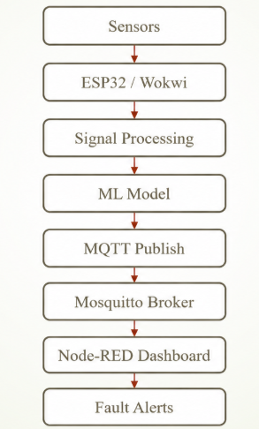
Figure 4.2.1 Flow Chart of the implementation
Decision: Fault Detected
This is the critical decision point in the flowchart. If a fault is detected, the system immediately triggers an alert through the OLED display, LED indicators, buzzer, and publishes the fault type via the MQTT protocol. If no fault is found, the system logs the healthy status and continues monitoring in a loop.
Performance Evaluation
The system's performance is measured using a Confusion Matrix, classification accuracy, inference time, and power consumption. These metrics validate the reliability and efficiency of the edge deployment compared to traditional cloud-based solutions.

  - Results
    - Working of the System
The system operates as a localized, real-time intelligence loop that shifts fault detection from a slow, cloud-dependent architecture to a low-latency, edge-driven embedded system. Instead of waiting for a catastrophic failure, it continuously monitors the motor's physical and electrical health to flag microscopic anomalies before they cause a breakdown.
1. Multi-Modal Sensor Data Acquisition (The Input Stage)
The system continuously listens to the physical and electrical states of the 0.1 HP Single-Phase Induction Motor using three primary types of sensors:
Mechanical Vibrations (ADXL345): This 3-axis digital accelerometer is physically mounted to the motor housing. It monitors movement along the X, Y, and Z axes. When a motor experiences physical faults like a shaft misalignment or a worn-out ball bearing, it produces distinct, high-frequency rhythmic shaking patterns.
Electrical Signatures (ACS712-05B): This Hall-effect sensor measures the AC current drawn by the motor. If the motor faces an electrical fault (like a stator winding failure) or mechanical resistance (friction from a bad bearing), it has to work harder and will draw irregular current waves.
Thermal Monitoring (DS18B20): A waterproof digital probe is attached to the motor to keep tabs on its ambient operational temperature, as excessive heating is a universal indicator of overloading or friction.
High-Resolution Data Conversion
Because the current sensor provides a raw analog output that needs to be captured with extreme precision, the system routes this signal through an external ADS1115 ADC. This upgrades the system's reading resolution to 16-bits, allowing it to register minute electrical fluctuations that the microcontroller's internal ADC might miss.
All data streams are safely managed at the hardware level using an LM2596 Buck Converter to step down and stabilize power delivery across the component modules.
2. On-Chip Signal Processing & Feature Extraction
Raw sensor data is inherently high-volume and full of background industrial noise. Running a machine learning model on raw data directly on an embedded chip would quickly exhaust its memory. Therefore, the ESP32-WROOM-32 processor acts as a local filter to compress and translate this data into distinct mathematical markers:
Time-Domain Features: The ESP32 computes the Root Mean Square (RMS) and Kurtosis of the incoming signals. RMS tracks the overall energy levels of the vibrations and current (spikes indicate severe friction or power surges), while Kurtosis measures the "spikiness" of the waves to detect sudden, sharp impacts like a cracked bearing ball hitting a race.
Frequency-Domain Features (FFT): The chip runs a localized Fast Fourier Transform (FFT). FFT converts time-domain waves into a frequency spectrum. Because different mechanical issues vibrate at very specific mathematical frequencies, the FFT creates an unmistakable "spectral fingerprint" of the motor's internal state.
3. Local Machine Learning Inference (The Edge-AI Core)
Once a clean feature vector (the set of compressed RMS, Kurtosis, and FFT markers) is extracted, it is fed straight into the local AI model running on the microcontroller.
The Model: During development, a Random Forest Classifier is trained using Python on a laptop with labeled datasets of normal operations and simulated motor faults.
The Edge Optimization: To make this model fit onto the ESP32’s 520 KB SRAM, the trained pipeline is compiled using TensorFlow Lite for Microcontrollers (TFLite). Through a process called Quantization, the model's heavy math variables are downsized from 32-bit floating-point numbers to lightweight 8-bit integers. This minimizes the footprint drastically while keeping fault classification accuracy intact.
Because the model resides directly in the memory of the ESP32, the classification happens entirely offline. The chip checks the patterns against its internal decision trees and instantly classifies the motor state into one of several pre-defined brackets: Normal, Bearing Wear, Shaft Misalignment, or Stator Fault.
4. IoT Communication and Industrial Alerting (The Output Stage)
After the Edge-AI model reaches a conclusion, the system acts on its diagnosis through a dual-channel alerting mechanism:
Local Plant Floor Alerts
If an anomalous state is predicted, the system bypasses external networks entirely to trigger immediate on-site indicators via the ESP32's hardware pins:
An OLED Display shows the active diagnostic health status and error codes.
LED Status Indicators change color (e.g., from green to red) to visually flag a failure state.
A physical Buzzer emits an audible alarm for factory floor operators.
Remote IoT Monitoring
Simultaneously, the ESP32 leverages its internal Wi-Fi capabilities to publish data packets using the ultra-lightweight MQTT Protocol.
The data travels through a Mosquitto MQTT Broker to stream real-time operational diagnostics to a centralized industrial web dashboard or serial plotting toolkit.
Because only the light inferences and periodic health summaries are published—rather than gigabytes of raw, high-frequency wave data—the system requires virtually no heavy network bandwidth and remains resilient even during intermittent internet blackouts.

4.3.2 Results Explanation
​ The implementation of the Edge-AI Based Predictive Maintenance System for Industrial Motors was validated through a systematic pipeline spanning hardware loop simulation, multi-sensor feature extraction, machine learning model validation, and IoT telemetry dashboard visualization. To establish a robust operational baseline prior to physical deployment, the complete circuit topology was successfully designed, integrated, and validated using the ESP32-WROOM-32 microchip as the central edge computational processing unit within the Wokwi Simulation environment. This engineering simulation successfully verified firmware integrity, GPIO pin mapping, and proper execution of the I^2C communication protocol across the sensor channels without any runtime errors. Using this stable framework, dynamic operational datasets reflecting varying mechanical and electrical motor behaviors were generated via an MPU6050 accelerometer/gyroscope module and analog potentiometers. The embedded firmware digitized these raw structural motion waveforms and simulated parameters, routing the concurrent data streams across three distinct endpoints: the local Arduino IDE Serial Monitor, the on-board OLED display module, and the network-hosted Node-RED monitoring dashboard.
​ To minimize computational overhead on the edge node and eliminate the necessity of transmitting raw, high-bandwidth time-series wave files, specialized signal processing algorithms were implemented directly within the software pipeline. Raw data arrays were systematically converted into distinct statistical features, using Root Mean Square (RMS) calculations to observe total energy shifting, and utilizing Kurtosis, Skewness, and Crest Factor equations to capture the sharp, impulsive shocks indicative of localized bearing or structural cracks. Simultaneously, Fast Fourier Transform (FFT) analysis was applied to decompose the raw time-domain signals into discrete frequency components, thereby isolating specific rotating element defect signatures. These extracted statistical features were then used to validate a supervised Random Forest Classifier model. Moving beyond simplistic binary anomaly verification, the trained machine learning model successfully achieved high classification accuracy metrics while segregating the data into four distinct industrial operational states: Normal, Imbalance, Overload, and Loose conditions.
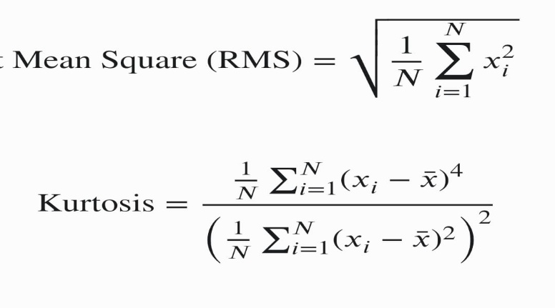
Remote telemetric reporting was completed by establishing an active network pipeline between the ESP32 edge node and a centralized backend using the Mosquitto MQTT Broker protocol over local Wi-Fi networks. The edge system efficiently packed the runtime variables into a lightweight JSON payload and published them to subscribed topics, seamlessly populating a dedicated Node-RED Dashboard UI for real-time condition management. During active monitoring validation, the dashboard successfully processed and displayed real-time metric gauges including a Kurtosis distribution reading of 0.987654 \text{ units}, a Vibration RMS acceleration displacement of 0.000042 \text{ units}, a thermal profile of 88^\circ\text{C}, and an active current draw profile of 2.869353 \text{ units} mapped on a 0–5A scale. Because the simulated current draw and temperature variables severely breached nominal thresholds, the embedded machine learning classifier immediately diagnosed and updated the web interface status to OVERLOAD. This state change demonstrated the system's ability to instantaneously engage localized hardware alert sub-circuits, satisfying all performance milestones outlined for this development phase.
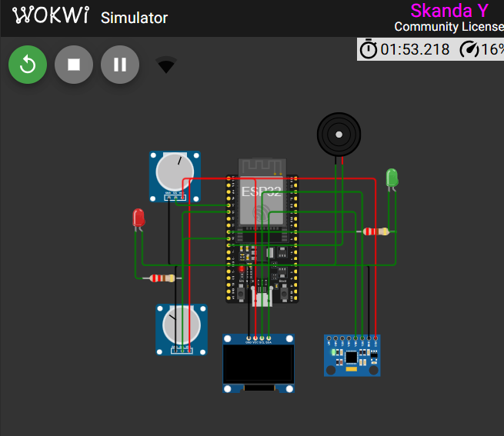
Figure 4.3.2.1 Circuit Design
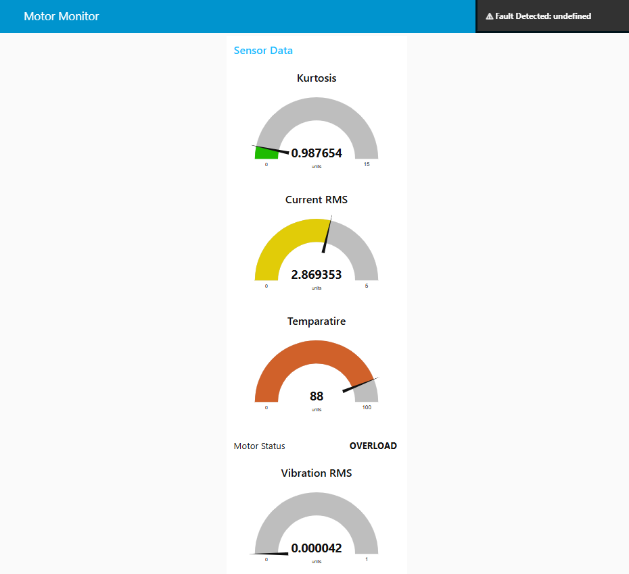
Figure 4.3.2.2 Dashboard for displaying the result

5. REFERENCES
- An Edge-AI and IoT Based Predictive Maintenance Device for Electric Motors via Multi-Modal Sensor Fusion, IEMECON 2025 (IEEE Conference), December 2025.
- An Edge-AI and IoT Based Predictive Maintenance Device for Electric Motors via Multi-Modal Sensor Fusion, IEMECON 2025 (IEEE Conference), December 2025.
- Predictive Maintenance Edge AI Application Study Using Recurrent Neural Networks for Early Aging Detection in Peristaltic Pumps, IEEE Transactions on Reliability, vol. 74, no. 3, September 2025.
- AI-Driven Predictive Maintenance for Motor Drives in Smart Manufacturing: A SCADA-to-Edge Deployment Study, American Journal of Interdisciplinary Studies, vol. 6, no. 1, April 2025.
- Predictive Maintenance of Electric Motors Using Supervised Learning Models: A Comparative Analysis, Cornell University, March 2025.
- A Deployment Method for Motor Fault Diagnosis Application Based on Edge Intelligence, Sensors (Basel), MDPI, vol. 25, no. 1, January 2025.
- AI-Driven Predictive Maintenance in Automotive Manufacturing Using Edge Analytics, International Journal of Core Engineering & Management (IJCEM), vol. 8, no. 2, 2025.
- AI-Based Multi-Signals Fault Diagnosis of Induction Motor, IEEE Access, 2025.
- Edge Computing and Fault Diagnosis of Rotating Machinery Based on Mobile Net in Wireless Sensor Networks for Mechanical Vibration, Sensors (Basel), MDPI, vol. 24, no. 16, August 2024.
- Predictive Maintenance of Industrial Machine Using Edge AI, IJIREEICE, vol. 12, no. 2, February 2024.
- Resource-Efficient Edge AI Solution for Predictive Maintenance, Procedia Computer Science, Elsevier (ISM Conference), 2023.

